11/29/2018 | Spanish 3rd and 4th grade
Saludos,
This is my December newsletter for the year and I would like to share what we have been learning in our Spanish classes in the past several weeks.

Lesson 4 El chocolate caliente
The students learned how to make chocolate caliente, and we had an authentic experience preparing and drinking hot chocolate, using a Mexican brand called Ibarra and an authentic utensil called un molinillo (see below). At home, if you would like to prepare this yummy Mexican treat that is great for cold winter days, try the brands Ibarra or Abuelita, which you can find at La Tienda de la Libertad on Liberty. You heat up a large saucepan with milk and let the chocolate melt into it. Mexican hot chocolate is spicier than the hot chocolate we’re used to. It has a delicious flavor of dark chocolate and cinnamon. Here is a link to the vocabulary in this lesson. And BATE, BATE, CHOCOLATE is a fun, simple authentic song perfect for this theme!
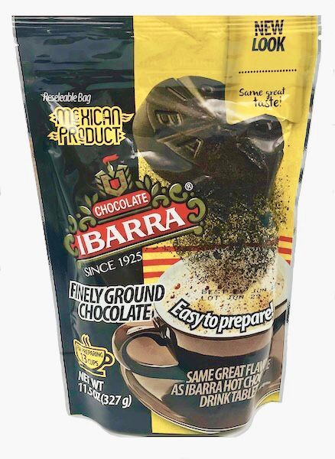
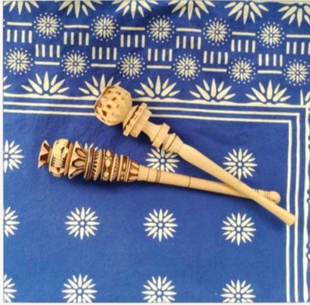

Lesson 5 El Día de los muertos
In this lesson we learned about the traditions of El Día de los Muertos (The Day of the Dead). One of them is making ofrendas. Here is the story I introduced the vocabulary for making una ofrenda (an offering) with. We also observed the Day of the Dead traditions with the movie Coco. The Spanish version of the movie is available on Netflix. Here is a link with the vocabulary that we have used in class.

Lesson 6 La comida
In this lesson we learned how to express preferences regarding food using the expressions me gusta, me gusta mucho, me gusta más, no me gusta. We focused on the vocabulary for los postres (desserts) with two mini books: Helado and Javi come mucho. We also learned about the la lonchera (the lunch box) with the mini book El almuerzo de Pepita, and about school lunches in some Spanish speaking countries. Here are the links for the vocabulary for postres and for la lonchera. The students learned how to say what is in their lunch box, using hay (there is/there are) and some of this extra vocabulary.

Lesson 6 La comida
In this lesson we learned how to express preferences regarding food using the expressions me
Want to insert a picture from your files or add a shape, text box, or table? You got it! On the Insert tab of the ribbon, just tap the option you need.

Lesson 7 El Día de Acción de gracias (Thanksgiving)
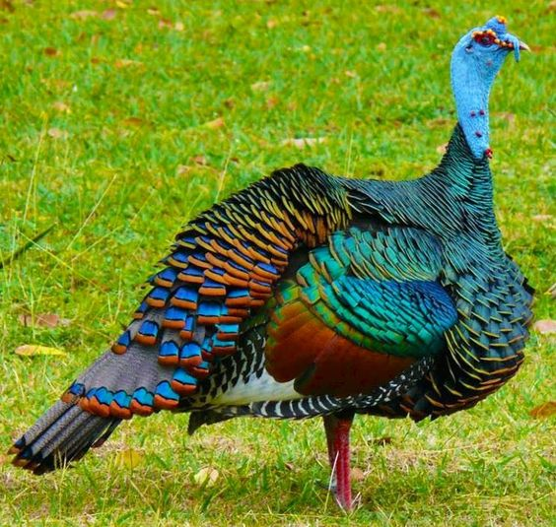

In this lesson we compared los pavos (the turkeys) in the United States and in México. The turkeys in México are very colorful, so I introduced the vocabulary words for the different colors. The students worked on a small project too. They traced their hands, cut out the hand shape and wrote about five things in Spanish that they are thankful for, using Doy gracias por… (I am thankful for…). I gave them a list with vocabulary suggestions like the names for the different family members and for things from the nature. I used their traced hands to create the plumage of a turkey on the bulletin board outside of our classroom. Here you could find the vocabulary set for colors and for things to be thankful for.

Next, we will begin the unit about pets.

A very happy new year to all! May 2019 bring you much joy.
¡Prospero Año!

Marieta

