- 3rd and 4th grade  April 10, 2019 | Spanish newsletter #5
Mis vacaciones  (My vacation) | Hola,  Happy Spring! With the March madness and the new season, it took me awhile to send this letter. I would like to share what we have learned so far in March and April in our Spanish classes. After learning about the different pastimes and hobbies in February, the kids learned how to play five traditional board games from México and Guatemala, such as Pitarra, Coyote, Alquerque, Bul and Patolli.  In March we focused on the unit Mis vacaciones (My vacation). The students learned the names of the different places in nature that they can visit for a vacation such as la playa (the beach), el campo (the countryside), la montaña (the mountain), etc. They learned how to describe these places, using the expressions Yo veo… (I see…) and Hay… (There is/are…) and the vocabulary for things in nature (example: la arena- sand). They also learned how to say why they want to go to these places for a vacation, using Quiero ir a _____ porqué me gusta _______ (I want to go to ______, because I like to _______) and different activities, such as construir un castillo de arena (to build a sand castle), elevar un volatín (to fly a kite), etc… We wrote post cards in Spanish describing an imaginary trip to a Spanish speaking country. Here is the vocabulary associated with this unit. As a cultural closure, the kids learned about the geographic formations, the flora and fauna that could be found in the National Park Canaima in Venezuela from the February edition of the Nonfiction Spanish Magazine Mira el Mundo.  I had the amazing opportunity to spend the entire Spring break traveling in Costa Rica from the Caribbean to the Pacific coast with a large group of students, some of whom were Ann Arbor Open 8th graders, so in connection to the unit Mis vacaciones I shared with my classes my impressions and experiences from visiting the rainforest, the beautiful volcano Arenal, the National parks Tortuguero and El Rincón de la Vieja, the Pineapple and Chocolate tour and many more.  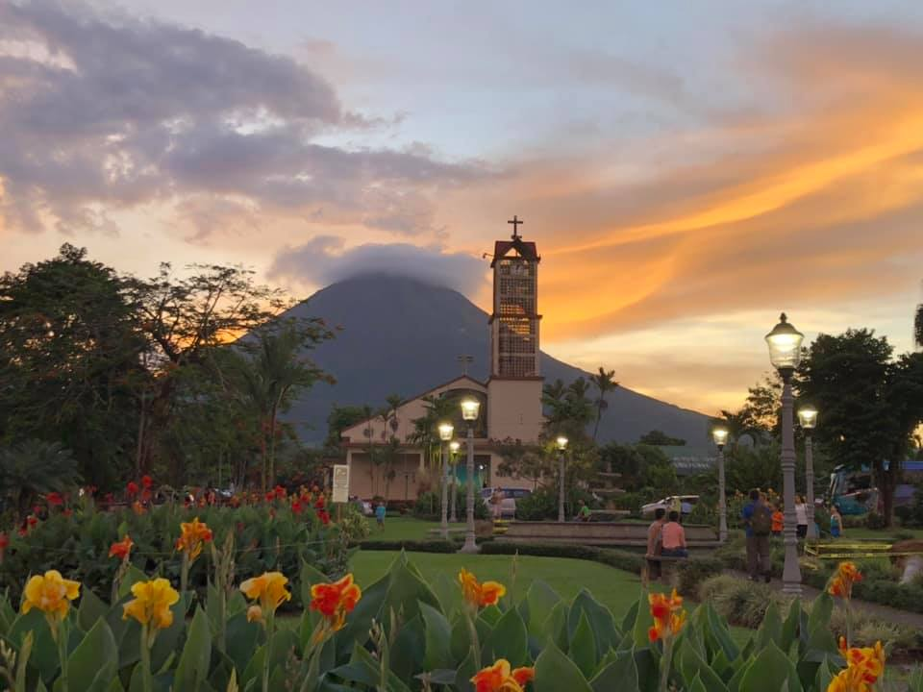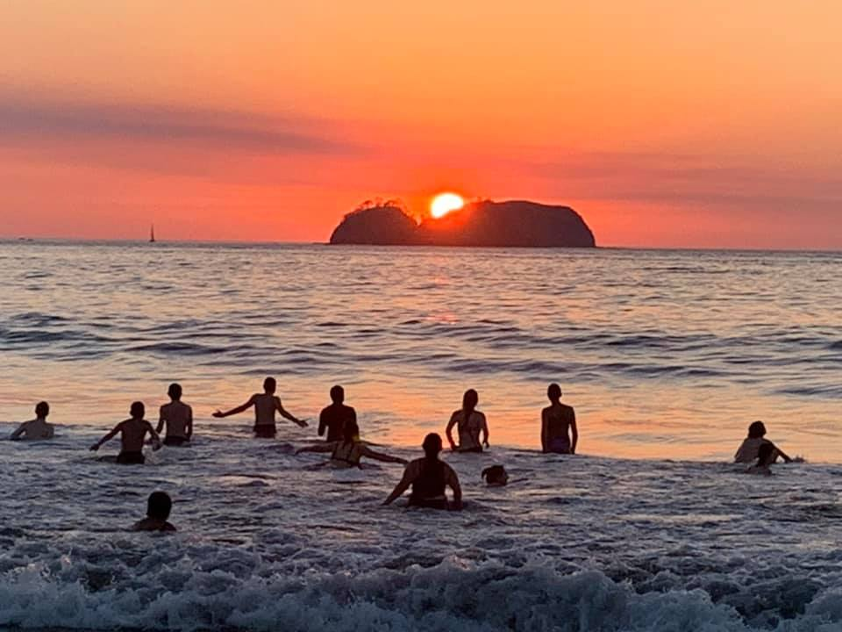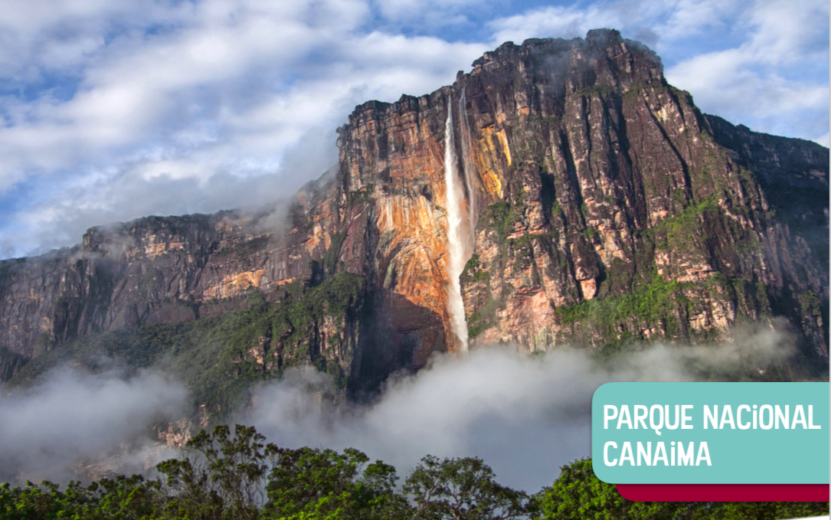  The volcano Arenal (Costa Rica) La Playa Hermosa (The Pacific coast) National Park Cainama (Venezuela)
Las Profesiones  (The Professions) | Also, in March during the Mardi Gras week the students learned about different carnivals and fiestas in Spanish Speaking countries and we decorated the masks associated with these celebrations.  In April we started the unit Las profesiones y oficios (The Professions) and the students are learning how to say what they want to be when they are older, using Cuando sea mayor, quiero ser ________ (When I am older, I want to be ________) and Voy a trabajar en _________ (I am going to work in _______) plus the vocabulary for the places to work. You could find the vocabulary for this unit here.  Kind regards,  Marieta

